STUDENT VISA SUPPORT REQUEST FORM
Please be sure to submit this form along with your admission application documents to the academic affairs office of your desired graduate school (graduate admission) or the Admissions Center (undergraduate). All students are required to submit this form. Please submit the form in either Japanese or English.

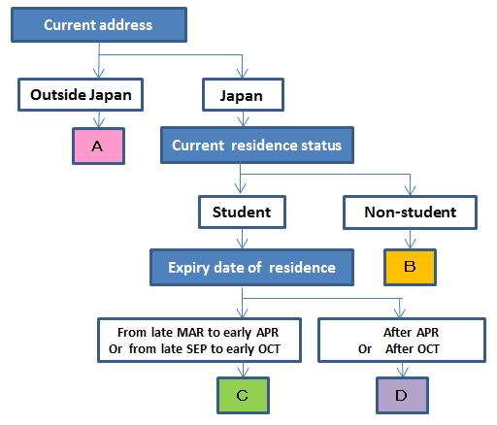
Category A: You have to apply for a student visa as soon as possible. If you have the intention to enroll in TMU after passing the entrance exam, you need to obtain a Certificate of Eligibility (COE) for visa application. TMU applies for it to Japan’s Immigration Bureau on behalf of you. The International Affairs Office will contact you to give information about further procedures after you pass the exam.
Category B: For those who want to change your status to ‘student’, you need to apply for a change of the Status of residence. After being enrolled in TMU, please come to our International Affairs Office with your student ID, residence card and the receipt for your tuition payment you made to the University.
Category C: You need to apply for an extension of the period of stay soon. Please come to our international affairs office with your student ID, residence card and the receipt for your tuition payment. If your period of stay is expired before March or September, you have to extend at the previous educational institution/employer.
Category D: You need to change the accepting institution to our university from the previous one. Further information about procedures will be provided at orientation for newly enrolled students.

Which do you fall under, Category A, B, C or D? Those who do not fall under any of the categories please contact us.
(NOTE): Applications for a COE, change of the status of residence and extension of the period of stay are screened case by case, therefore, permission is not always given. There is also a possibility that the permission is not given by the enrollment date. In these cases, TMU is not responsible.
Name (in English alphabets)
Name (in Kanji if any)
Date of birth | Gender | (Year)/ (Month)/ (Day) | Male / Female
Nationality
Status of residence (If applicable) |  | Yes / No (Type of Visa: )
Expiry date of status of residence |  | Valid until (Year)/ (Month)/ (Day)
Current educational institution/employer
Contact address
E-mail address (should be legible) |  | @
Contact phone No. (International phones applicable)
Name of desired faculty (school) / graduate school
Desired course |  | Undergraduate / Master’s / Doctoral / Research Student
Desired academic advisor
Signature of Applicant (data entry possible):
Contact: International Affairs Office
E-mail: tmu-coesupport@jmj.tmu.ac.jp
Phone: 042-677-2030 (direct)

(DATE Y / M / D)

